**School Spirit Order Form- Brookvale Elementary School**

**Purchase dates are: Sept. 29 – October 10**

**Name :_____________________________________________________Room #/Teacher:_________________________________**

If you wish to order one of the shirts below, please submit **CASH only** with this order form to your child’s teacher no later than October 10th. It is our goal to have the shirts to families by the second week in November. Please know that all purchases have a no return policy. All sizes are standard sizes for both youth and Adult. **Please staple your cash to this order form.**

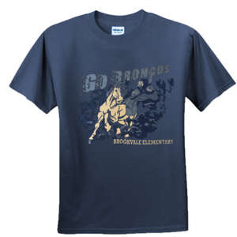**Youth** Size Short Sleeve T Shirt $10.00

Small______ Medium ______ Large ______ XL______ Total $ amount:_____________

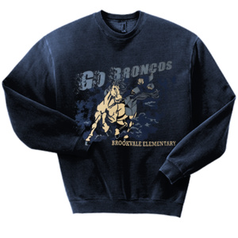 **Youth** Size Crewneck Sweatshirt $15.00

Small______ Medium ______ Large ______ XL______ Total $ amount:_____________

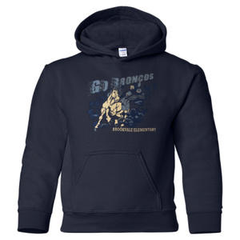 **Youth** Size Hoodie Sweatshirt $25.00

Small______ Medium ______ Large ______ XL______ Total $ amount:_____________

Adult Size Shirts

 **Adult** Size Short Sleeve T Shirt $12.00 (XXL= $15.00)

Small______ Medium ______ Large ______ XL______ XXL _____ Total $ amount:_____________

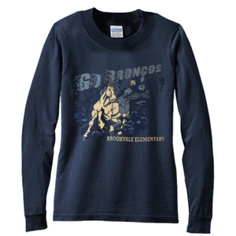 **Adult** Size Long Sleeve T Shirt $15.00 (XXL =$20.00)

Small______ Medium ______ Large ______ XL_____ XXL_____ Total $ amount:_____________

 **Adult** Size Crewneck Sweatshirt $25.00 (XXL= $30.00)

Small______ Medium ______ Large ______ XL______ XXL_____ Total $ amount:_____________

**Total money submitted for order:$_______________. Total items ordered:___________**